## Tiger Theatre



Tiger Elective Adventures: Tiger Theater

1. With your den, discuss the following types of theater: puppet shows, reader’s theater, and pantomime.

2. As a den, play a game of one-word charades with your adult partners.

3. Make a puppet to show your den or display at a pack meeting.

4. Perform a simple reader’s theater. Make a mask afterward to show what your character looks like.

5. Watch a play or attend a story time at a library.

## Planning a Puppet Show

*Trapper Trails Council*

**Week 1 -**

Come up with a theme or use the theme "Imagination Station" to let the boys write their own script for a puppet show. Encourage them to each participate and come up with different ideas that can be used. Make sure that there will be enough parts for each boy to use for their puppet.

**Week 2 -**

Decide on what type of puppets will be used. Keep it pretty basic to ease making the pattern and cutting out a puppet for each boy. If it's a person cut the pattern from flesh or pink felt, a dog, from tan or brown felt, etc. Then let the boys create their puppets with various odds and ends of felt, material, button, sequins, or whatever you can come up with. Ask for donations of odds and end from their parents or families. Glue the edges of the hand puppets together with low temp glue guns or thick tacky glue. Let them have fun with the glue to create their own puppets.

**Week 3 -**

Get a large appliance box and cut it so it has a front and two sides that will bend as wings to hold the box upright. Cut a large square hole in the front to form the window for your puppet show stage. Let the boys decorate the front of the box to go along with the theme of your script. If you're brave they could even paint it with poster paints.

**Week 4 -**

**Practice, Practice, Practice!** Make sure each boy knows their parts and cues so that they will be able to perform a puppet show for your pack meeting. The boys love to perform and this will be a project that they will remember for many years! Give each boy the chance to be an announcer, emcee, or narrator for your show! If your boys have been learning about magic tricks this would be a great time for them to show your den their talents in the magic area or save the stage and use it at a later date for a magic show that the boys can put on.

**Some prop ideas:** an empty oatmeal box with a cut out front oval can become a hollowed out log when covered when brown paper then cut out a silhouette of a bunny or squirrel and glue inside the oval.

Tip a card table on its side and put a scene on it.

**PANTOMIMES**



A fun way to start this activity is to have the Webelos Scouts stand in a circle. The leader makes an action, and the players exaggerate their version. Here are some suggestions to start with...then make up your own and have fun!

* -Say with your hand, “Stop.”
* -Say with your head, “Stop.”
* -Say with your shoulder, “I bumped the door.”
* -Say with your foot, “I’m waiting.”
* -Say with your ear, “I hear something.”
* -Say with your waist, “I’m dancing.”
* -Say with your jaw, “I’m surprised!”
* -Say with your tongue, “Yum, this tastes good.”
* -Say with your finger, “Come here!”
* -Say with your fingers, “This is hot!”
* -Say with your nose, “I smell fresh pie.”

**Some Basic Rules of Charades:**

* When you are acting out your charade, you must not speak or make sounds
* There should be a round time limit, usually about one minute
* Words and names should be known by at least three others playing
* Rules should be clarified before the game starts as there are many ways to play Charades

**Suggested Words**

Chair

Jump

Elephant

Scissors

Point

Star

Tree

Airplane

Tail

Basketball

Mouth

Telephone

Chin

Jar

Smile

Cheek

Ear

Drum

Room

Turtle

Wings

Doll

Bird

Spider

Hopscotch

Happy

Baby

Monkey

Pig

Jump

Crayon

Arm

Rabbit

Book

Camera

Rock

Chicken

Robot

Drink

Balloon

Dragon Puppet:   
Cut 2 wedges (v shapes) out of the sides of a paper or plastic cup to create the open mouth of the dragon. Using a nail, punch a hole in the top and bottom of the dragon. Slide a skewer through the holes so the dragon sits on the stick like a lollipop. Decorate the dragon with eyes, teeth, and an optional tongue. Tape a long ribbon(s) to the cup for the tail. (I used plastic surveyor’s tape, and cut points on the top ribbon and diamonds in the middle of the bottom ribbon. You can also use strips of plastic cut from a cheap plastic tablecloth.) The boys will have fun waving their puppets around, and watching the tails flutter and stream out behind the dragon. *From The Picture Book of Kids’ Crafts*

## Bug Finger Puppet

*Catalina Council*

**Materials:**

Craft Foam - You can also use felt.

Pom-Poms

Chenille Stems

Wiggle Eyes

Dimensional Paint

Craft Glue

Scissors

Wire Cutters or Old Scissors -   
*Used for cutting the chenille stems.*

****

**Directions:**

1. The body of the bug is made by cutting a piece of craft foam about 2-inches x 3-inches. This may vary depending on the size of the finger that will wear the finger puppet.
2. Wrap the 3-inch length around your child's finger and glue the edges together to make a tube which will be the bug's body, trim if necessary. Hold the glued edges together until the glue sets. It may be helpful to put a few dabs of hot glue on the edges to hold until the craft glue dries.
3. Place a bead of glue around the edge of one of the ends of the craft foam tube. Place the pom-pom onto the glue and let it dry.
4. Bend a short piece of chenille stem in half and glue it onto the bug's head for the antennae as shown in the photo. Glue on the wiggle eyes. You can also add other facial features such as a mouth, nose, and any other details you want.
5. If desired, cut a set of wings out of craft foam. Experiment with different shapes and sizes if you like. You can make them look like butterfly, bumble bee, dragon fly, or lady bug wings.
6. Glue the wings onto the back of the bug as shown in the picture. If desired, you can embellish the wings with dimensional paint, glitter, sequins, or just about anything else you like.
7. For the legs, cut six pieces of chenille stem, each about 1 1/2-inches long. Of course, if you are making a spider you will want eight legs instead of six.
8. Finally, you can glue the legs onto the bug. Flip your bug over and attach chenille stem legs using a generous amount of glue.
9. Once the glue dries, you can wear your bug finger puppet and have fun.

## Puppet Making Tips

*Indian Nation Councils*

**Scrap Puppets**

Scrap puppets are fun, easy and quick to make. Give an old sock a fresh look. Dress up a paper bag. Paint a face on an old wooden spoon and decorate it. To make finger puppets start with an old glove. Cut off the fingers - you know have 5 puppets ready to decorate. Use buttons, beads and pom-poms to make eyes and noses. Bottle caps and jar lids make hats or eyes or ears.

**Popsicle Puppets**

Take a Popsicle stick and paint the eyes, nose and mouth. Use lace to make the dress and wool yarn for the hair.

**Bee Puppet**

Put pom-poms on a yellow sock as the eyes. A pipecleaner serves as the antennae.

**Popsicle Puppets**

Draw any kind of character you want - a dog, cat, person, or anything. Cut it out and color it; then glue it to a Popsicle stick. You can also make a family and friends for your puppet.

**Cereal Box Puppets**

Cut one side of a SMALL cereal box in half (width) and fold the box towards the uncut side. This forms the mouth; your fingers fit into the top jaw; your thumb fits into the lower jaw. Add eyes. Lips, and hair. Drape scarf over your arm for clothes.

**Doll Puppets**

To make a doll/puppet, you will need scissors, two buttons, tights/socks, a piece of material/cloth, a red pen, a needle and thread, wool, a ruler and some rice.

Cut the tight, (up to the ankle), then fill the foot part most of the way up with the rice. Use some of the wool to tie up the end. This forms the face. Then sew the two buttons on the tip part (as eyes). Draw a mouth with the red pen. Cut the wool into 4-inch pieces and use the needle to sew the wool pieces on the head to make hair. Cut the cloth into the shape of a dress/t-shirt. Sew this onto the bottom of the face and then you have a doll/puppet.

**Decorating Puppets**

Use fabric paints to color things in or use it just like glue. You can also use dry foods such as spaghetti, elbow noodles, or spiral noodles for hair, eyes, noses, mouths, or hair. Use steel wool for hair to make witches. Straws and pipe cleaners are great for whiskers and antennae. Hair can be fashioned from yarn, string and rope. Old jewelry, ribbons and feathers will give your puppet an exotic look. Shells can make interesting eyes or ears. Seaweed hair is stylish and smelly! Nuts, bolt, washer, hooks and springs are neat attachments for making robot puppets.

## Talking Sock Puppet

*Catalina Council*

**Materials:**

Stretch sock, any size

Lightweight cardboard Buttons

Felt tip marker

Ball fringe

Ribbon scraps,

Yarn

Rubber cement for gluing

**Directions:**

1. Use the stretch sock to make the puppet's head and body.

2. Lay it flat on the table, heel side up.

3. Tuck about 2" of the toe back into the sock to form the puppet's mouth.

4. Sew a short seam on each side of the mouth opening to hold it in place.

5. Fold lightweight cardboard in half, sizing for the mouth, slip into puppet's head, forming top and bottom of mouth.

6. Slip the sock over your hand; your fingers will go above the cardboard at the top of the mouth, your thumb below the cardboard. Open and close your hand, puppet talks.

7. Add buttons for eyes, yarn for hair, and ball from fringe for nose.

**Make an Otter Puppet**

example_puppet_otter **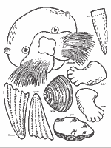**

**This paper bag puppet of an otter is easy to make – and did you know that an otter is an animal that really uses Resourcefulness every day?**

The otter loves to eat crabs and clams, but has no way to open the hard shell. So he dives to the bottom, picks up a good rock, then returns to the surface and uses the rock to smash open his dinner!

Also, he uses special “pockets” – flaps of skin under each front leg, to stash his dinner during a dive.

And in one more example of resourcefulness, the otter floats on his back and uses his own stomach as a table!

Another resourceful habit of the otter – in order to catch a safe nap without floating away, he wraps himself in the kelp!

Here’s how to make your otter puppet.

For more information about sea otters, other activities and how to make your puppet, go to: [**www.montereybayaquarium.org/lc/activities/otter\_puppet.asp**](http://www.montereybayaquarium.org/lc/activities/otter_puppet.asp)

## Paper Bag Frog Puppet

*Catalina Council*

**Materials:**

Paper lunch bag

Printer and paper

Green paint (or construction paper)

Scissors

Glue and/or tape

Something to color with

****

**Familiarize Yourself With The Bag:**

1. Look at your paper bag. It should be closed and flat like a piece of paper. Just like when they are brand new. On one side, it's all smooth. This will be the BACK of your puppet. It's important that all the kids get the back and front straight at the beginning!
2. On the other side there's a flippy tab (which is typically the bottom of the bag when you're carrying your lunch around...) This flippy tab will be the puppet's HEAD.
3. Lift the flippy tab up a bit. Underneath of the FLAP will be the puppet's mouth. When the child put's his hand in the bag, he'll be able to make the puppet talk.
4. Look at the rest of the front of the bag. (The 3/4 or so of the bag below the part with the flippy tab) This will be the BODY.
5. Look at the sides of the bag. There should be a SIDE FLAP of paper. We'll be slipping the arms into this flap.

**Putting The Puppet Together:**

1. Paint the front of your paper bag green.
2. Set aside to dry. OR As an alternative to painting, trace the body of the paper bag and the head of the paper bag onto green construction paper. Cut it out and glue it to the bag.
3. Print the template pieces. Template pieces are at the end of Baloo's Bugle.
4. Color the largest circles and arms green (or whatever color your frog is going to be.
5. Color the long rectangle (ish) piece red (FRONT AND BACK!)
6. Color the smallest circles black
7. Cut out the pieces.
8. Put one of the green circles in front of you. Glue the medium sized (white) circle onto it. Glue the small (black) circle onto that. Repeat with the other set of circles. Now you have two eyes!
9. Take the red long rectangle and wrap it around a pencil to give it a curl. This will be the tongue.
10. By this time, your bag should be dry. Glue the eyes onto the top of the HEAD. You can see from the photo above that the eyes stick up over the top of the head.
11. Lift the FLAP and glue the tongue underneath.
12. Glue the arms into the SIDE FLAP. When you do this, glue or tape them onto the top of the flap not the bottom. That way when you're using the puppet, it's arms will reach forward in a hugging motion instead of bending way backwards.
13. OPTIONAL: You can personalize your basic frog puppet in a lot of ways
14. Put a construction paper or gift wrap bowtie on the frog.
15. Draw marker or paint speckles/warts/dots on your frog's body.
16. Take a small black pom pom. Attach some wax paper wings and small googly eyes to make a fly. Glue it to the frog's tongue.
17. Glue something into the frog's hand.
18. Put a small piece of Velcro on the frog's hand. Put Velcro on numerous objects. That allows you to change the frog's "props" during a puppet show. *If you chose to do this, you'll want to back the frog's arm with a thin piece of cardboard (old cereal box) so it doesn't flop around.*
19. Glue some construction paper froggy feet to the bottom of the bag.

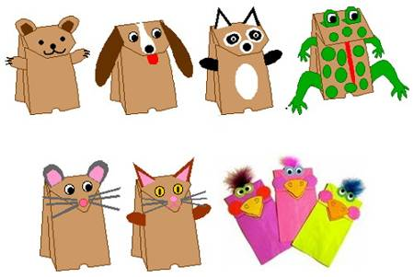

For more Paper Bag Puppet Instructions - Go to -   
[**www.enchantedlearning.com/crafts/puppets/paperbag/**](http://www.enchantedlearning.com/crafts/puppets/paperbag/)

## Make a Puppet Theatre

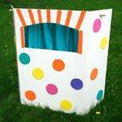

This is a really simple-to-make Puppet Theatre I got from <http://ziggityzoom.com> .

**Adults need to be involved. Cutting involves using a sharp blade so that I suggest Adults do the cutting BEFORE the den meeting.** Have scouts do the final construction and decorating of the theatre.

Make it from a large cardboard box or an inexpensive Foam display board from an office supply store.

Items needed:

* Large box or Foam Display board (foldable)
* Wood dowel or old broom handle (32" long)
* X-acto knife (only to be used by Adult)
* Pencil and Ruler
* Scissors
* Craft Foam
* 2 pillowcase for curtains  (optional - use only one)
* Craft glue (tacky white)

Instructions:

1. We used a foam display board, available at office supply stores for about $10-$12. It measured 36" tall and 24" wide in the front (sides are 12" wide).  You may also cut apart a large box that is roughly this same size, so that you will have a front and two sides that will fold.
2. Draw an opening that is (23 inches from the bottom) 9 inches high and 18 inches wide.  This opening can either be squared off at the top or arched like ours.   With a piece of board underneath the area to be cut out, carefully cut the opening with an X-acto knife.   ADULTS SHOULD DO ALL CUTTING. Children should be a distance away while this is being done.
3. You will also have to cut a small hole (about the size of a cork) on each side piece, about an inch from the top.  This is to slide the dowel through to hold the curtain.   The hole should be about 5 inches back from the front edge.
4. Using the craft foam, cut out pieces to decorate the theatre and attach with glue.
5. For curtains, cut a two inch, skinny slit (at the closed end) on each side of the pillowcases.  This will allow you to slide the pillowcases onto the dowel and then position the dowel into the side openings.  If you prefer to only use one pillow case, you can cut the side and top of the case and then fold fabric out flat to make a larger piece of fabric.  About an inch from the top, and about 4-5 inches apart, make holes just big enough so that the dowel will slide through.  Cut a few slits to accommodate arms of puppeteer.



## Sock Puppet with Hands

*Catalina Council*

**Materials:**

Tube socks, no shaped heel

Yarn

Paper toweling

Rubber bands

Strip of ball fringe

Scraps of felt, ribbon, fabric

Felt tip markers,

Rubber cement

**Directions:**

1. Use the tube sock to make the puppet's head and body.

2. Before beginning, cut away the striped design at the top of the sock.

3. Stuff paper toweling, tissue or cotton into the toe to form the puppet's head.

4. Double a rubber band tightly around the neck.

5. Glue or sew small, dark buttons for eyes. For a nose, glue on a yarn ball cut from strip of ball fringe. Draw mouth with felt marker.

6. Make a yarn wig, any color, and glue it to the puppet's head.

7. Slip the sock over your hand. Work first finger through the rubber band and up into the puppet's head. L Then cut small slits in sides for the thumb and middle finger; these will be the puppet's hands.

**Fire Fighter Finger Puppet**

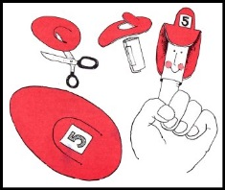

**Materials:**

**white paper, scissors, glue or tape, red** [construction paper](http://www.alphabet-soup.net/firesafety/firesafety.html) **or felt, black and red** [markers](http://www.alphabet-soup.net/firesafety/firesafety.html)

**Directions:**

1. **Cut a rectangle measuring 2 1/2" x 3 1/2" out of white paper.**
2. **To form cylinder, wind the rectangle around your finger.**
3. **Remove from finger and glue or tape the cylinder together.**
4. **Reproduce the hat pattern below.**
5. **Cut out and trace on red construction paper or felt. This will be the firefighter's hat.**
6. **Put scissors through the paper or felt; cut out the arc shape.**
7. **Glue the front of the hat and the back onto the cylinder, the arc extending out. (see illustration)**
8. **Add firefighter's features on the cylinder using a black marker and shade the cheeks with a red marker.**
9. **Write the fire squad number on a small white square and glue it to the arc.**

## Styrofoam and Drinking Straw Puppet Craft

*Catalina Council*

**Materials:**

Clean Styrofoam trays - if you can find   
colored trays, they make great puppets.

Scissors

Drinking straws

Pens, gel pens, or markers

Tape

Optional -   
Googly eyes and a glue stick  
Construction paper to make details,   
 like a mouth, hat, etc.  
Yarn for whiskers or hair

****

**Directions:**

1. Clean a Styrofoam tray with warm water and detergent.
2. Use a pen to draw the outline of an animal (head or entire body), person, or something else on the tray. A simple circle or oval with ears will make most animal heads.
3. Cut out the outline.
4. For the puppet's details (like the nose, eyes, mouth, whiskers, or a hat), either draw them with a pen (or marker), or cut them out of construction paper and glue them on the puppet.
5. To make hair or whiskers, glue on bits of yarn.
6. Glue on googly eyes using glue or draw eyes.
7. Tape the back of your Styrofoam animal to the end of a drinking straw.
8. You now have a great animal puppet that you can use to put on a play or use while reading your favorite story.

## Zany Sock Puppets

*Santa Clara County Council*

**You will need:**

* Adult-size sock (tube sock works best).
* 8 oz. Yogurt container, large plastic cup, or a section of large cardboard tube.
* Styrofoam ball smaller than the diameter of the container or tube (or you can make a tight ball out of newspaper).
* Dowel or bamboo plant stake (cheaper.)

**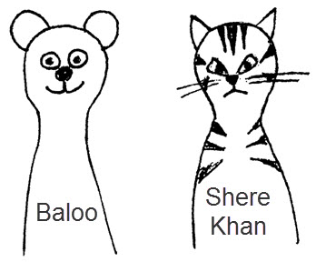**

**To Assemble the Puppet:**

1. Make sure the head piece is smaller than the diameter of the container. It needs to go down the container at least part-way with the sock too.
2. Glue the dowel or plant stake into the Styrofoam or newspaper ball.
3. Stuff the ball into the toe of the sock.
4. If using a container or cup, poke a hole in the center of the bottom large enough for the stick.
5. Insert the stick through the tube, container or cup.

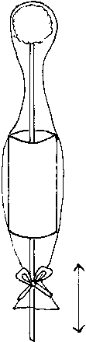

1. Pull the sock over the tube/container/cup. Secure the sock below the tube with ribbon or glue.
2. Move the stick up and down and have a puppet play.

**To Make an Individual puppet:**

* Glue specified pieces using illustration as guide.
* You don’t have to use specified pieces.
* Improvisation is encouraged!!
* Make up your own different animals.
* Have fun and make it fun for the boys!!!!

**Suggestions:**

* **Eyes:** Wiggle eyes. Felt pieces. Buttons. Rhinestones. Pompom and felt (Frog)
* **Nose:** Pompoms (pink, black). Felt pieces.
* **Ears:** Felt pieces, same color for the outer ears, pink for the inner ears.
* **Cheeks:** Pompoms. Felt pieces.
* **Mouth**: Rickrack. Felt pieces.
* **Collars**: Ribbon. Felt pieces. Rickrack. Rhinestones (cat’s collar). Scrap fabric (Tiger).
* **Whiskers:** Pipe cleaner (inserted through sock face). Rickrack. Thick yarn.
* **Antenna:** Pipe cleaners glued to the head piece through sock and pompoms.
* **Body:** Rickrack. Ribbons. Felt pieces.
* **Caps:** Ankle part of another sock drawn together and a pompom.

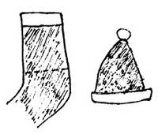

* **Straw hat:** Store-bought, available at a craft store. Attach ears to the hat (Rabbit).

**Newspaper Puppets**

*Circle Ten Council*

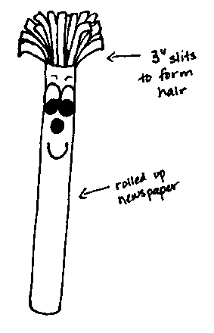

**Materials:** Newspaper, scotch tape, and white paper

**Directions**:

* Pile at least five pages of newspaper together.
* Fold them in half (so they are about 11 x 14) and roll them up lengthwise. Make sure that the roll is tight.
* Fold another page in half and wrap it around the roll.
* Tape them all together.
* From the top of the roll, make cuts about three inches long and 1/2 inch apart to make the hair.
* Draw eyes, nose and mouth on the white paper and cut them out. Glue the facial features on the roll just below the hair.

## Paper Bag Puppets

*Lynne, 21 year veteran,   
Den Leader Breakout Session Leader  
 Old Colony District Roundtables*

**Materials required:**

* 1 paper lunch bag, approx 5.5 inches by 10 inches
* Printout which includes head and body or a good imagination to help boys draw what they want
* Crayons, colored pencils, etc for decorating
* Scissors, tape or glue



**Directions:**

The puppet is made using the rectangular bottom of the paper bag for the face of the puppet, with the flap still mostly folded down. By putting a hand in the bag and curling fingers down over the fold, you can make the puppet 'talk.'

Each puppet comes with two sheets of paper, which have the head, the chin/mouth, the body and arms and legs printed on them. Also in the lower comer is a reference graphic of the assembled puppet.

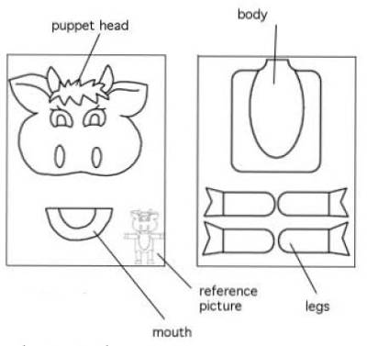

**Make your puppet:**

1. Color the head, mouth, body and limbs.
2. Cut out the different parts.
3. Attach the head to the bottom flap of the bag You might extend the puppet 's nose a bit past the bottom edge of the flap. DO NOT put any glue on that part, you want the flap to move freely. Some heads, like a bird or mouse, might have a beak or nose that will extend below the flap edge.

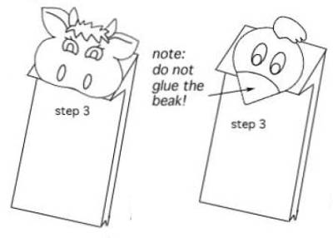

1. Position the body on the bag, fasten in place,

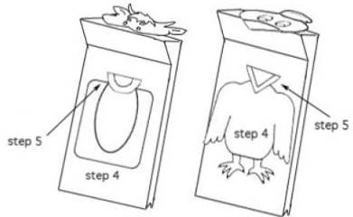

1. Position the mouth; it is attached to the base of the bag, and will generally cover the neck of the body, For some animals, such as the cow shown, you will want part of the lips/mouth to show even when the mouth is 'closed', For other puppets, like a bird, the lower mouth should be aligned behind the beak/mouth of the head.
2. Attach any arms/legs/wings as needed.

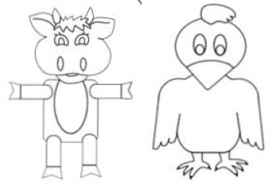

## Puppets with Hands

*Catalina Council*

**Paper Bag Sock Puppet**

**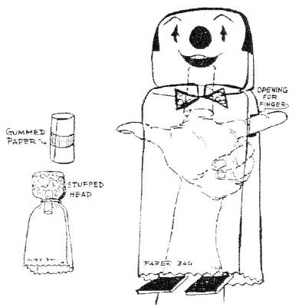 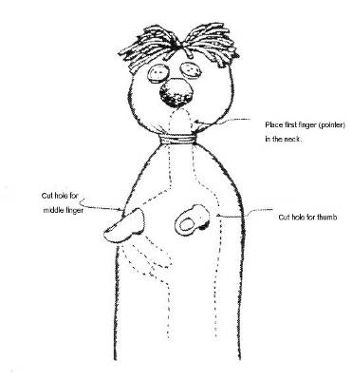**

**See-through Shadow Puppets:** Cut puppets out of white paper. Decorate one side with markers. Lay the puppet on a paper towel. Dab oil on both sides of puppet with a paper towel; let soak in. With a clean paper towel, wipe the excess oil off puppet. Color a brad with permanent markers to match the puppet. Push the brad through the puppet. Open the brad slightly, and push a pencil between the 2 metal tabs to open them. Put the top of a flexible straw between the 2 tabs, and tape the straw to the tabs. Bend the straw. Hold the puppet next to the sheet to get the best see through effect

Diwali Door Hangings: <http://www.crayola.com/lesson-plans/detail/diwali-doorway-lesson-plan/>

<http://diwali.best2india.com/diwalidoorhangings.html>

Diwali Decorations: <http://www.diwalimela.com/celebrations/crafts/>

You could also glue sequins or beads to the diyas (clay pot candle holders).

## Make Unusual Finger Puppets

*http://www.favecrafts.com*

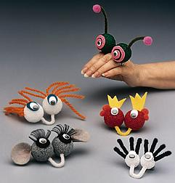

Materials:

* STYROFOAM Brand Products:
  + 2- 1" or 1-1/2" balls
  + 1- block (optional)
* 1- 3" piece of chenille stem
* 1- pair wiggle eyes
* Craft paint stiff paint brush
* Felt scraps
* Craft materials such as eyelash curls, pom-poms, yarn
* General Tools and Supplies:
* Scissors
* Craft glue or glue gun and glue sticks
* Wooden skewers or toothpicks

Instructions:

1. If desired, paint balls of STYROFOAM. Push a skewer into the balls to hold while painting; place skewers in a block of foam to hold while balls dry.
2. Shape 3" piece of chenille stem into a "U". Dip ends in glue and insert U shape into 2 balls so U shape will slip under the wearer's middle finger while the two balls sit on top of the hand to form the puppet's eyes. (1" balls work best for smaller hands.)
3. Cut felt shapes for eyes; glue wiggle eyes to felt or attach wiggle eyes directly on plastic foam balls. Glue on other features such as pom-poms and eyelash curls, or felt ears and eyelids.
4. Dab glue onto foam and use a skewer to push materials such as yarn into the foam for hair. Insert chenille stems into foam for antennae or eye lashes. For antennae, gently curve chenille stems and glue pom-poms onto the tips of shaped chenille stems; dip in glue and insert into foam.
5. Modify the finger puppet instructions to create a finger friend that resembles your school mascot, favorite pet or other character. Buttons, sequins or glitter are other objects that might inspire your creativity.